**Content**

* **ITX-Tanky**
* **Components**
* **Tank Component**
* **Pump Component**
* **Mobile App**
* **System Iterface**
* **ITX-Tanky**

**Vision:**  to achieve the goals automating water pump and seeing tanks status on mobile app.

* **Components**

ITX-Tanky project comprised on following components.

* Tank Component
* Pump Component
* Mobile App
* **Tank Component**

**Working:** When it powers on, it worked as both as “Access Point” and “Station”. it connects with pump component and send its information to pump.

**Functionality:**

1. Sense level of water and calculate level in percent. (done)
2. Sending data to pump when water level changes. (done)
3. Provides interface to change height and name of tank by mobile application. (incomplete)

e.g.

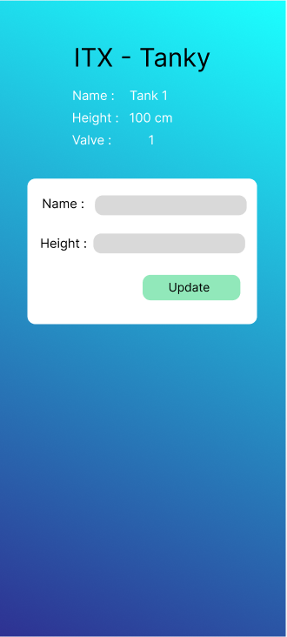

**Technical Requirements:**

* Store three things valve_no, tank_name, tank_height
* Calculate water level in percent (also include safety distance in calculation)
* Send info to Pump component when water level changes (info: “valve_no, tank_name, level”)
* **Pump Component**

**Working:** when power supplied to it, it worked as “Access Point”. Provides the websocket API like “ws:192.168.4.22:9500” to connect the tank components with it. Automate the water pump according to the tank’s water level. And also provides tanks info to the mobile app.

**Functionality:**

* At a time 4 tanks can connect with pump. (done)
* Receive Tanks info and store at run time. (done)
* Remove Tank info when Tank disconnect. (done)
* Store pump status. (done)
* Make decisions according to Tanks info. (done)
* Send Tanks info to mobile app. (incomplete)
* **Mobile App**

**Working:** work in android phone, connect with both tank component and pump component.

**Functionality:**

* When connect with tank component, provide interface to update the name and height of tank.

e.g.



* When connect with pump component, showing tanks status and interface to manually operate the pump.

e.g.

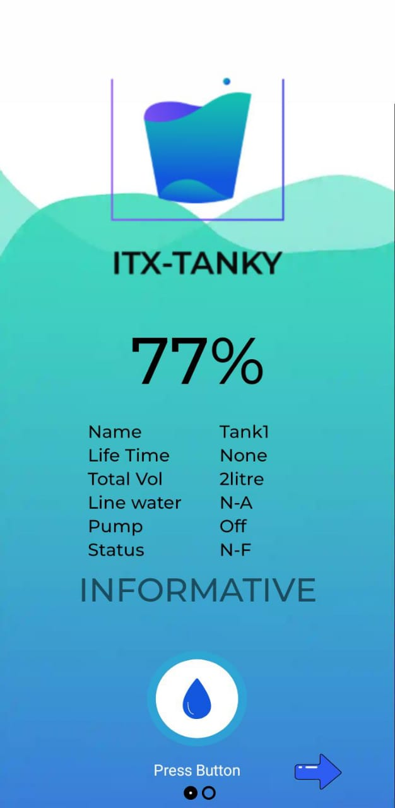

* **System Interface**

